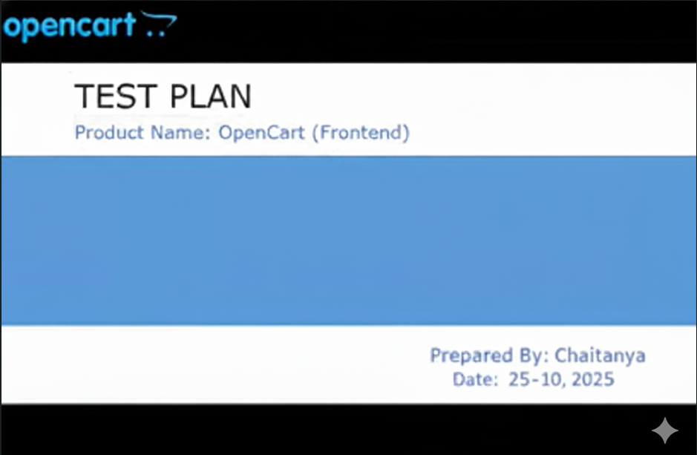
Table Of Contents:-
S.No |  | Section / Sub-Sections | Page No
1. |  | Overview
2. |  | Scope
2.1. |  | Inclusions
2.2. |  | Test Environments
2.3. |  | Exclusions
3. |  | Test Strategy
4. |  | Defect Reporting Procedures
5. |  | Roles / Responsibilities
6. |  | Test Schedule
7. |  | Test Deliverables
8. |  | Pricing
9. |  | Entry and Exit Criteria
10. |  | Suspension and Resumption Criteria
11. |  | Tools
12 |  | Risks and Mitigations
13. | Approvals

Overview:-
As part of the project, ‘OpenCart’ asked Chaitanya to test few functionalities of https://demo.opencart.com/ web application.
This document serves as high-level test planning document with details on the scope of the project, test strategy, test schedules, and resource requirements, test deliverables and schedule.
Scope:-
The scope of the project includes testing the following features of https://demo.opencart.com/ web application.
Inclusions:-
- Register
- Login & Logout
- Forgot Password
- Search
- Product Compare
- Product Display Page
- Add To Cart
- Wish List
- Shopping Cart
- Currencies
- Home Page
- Checkout Page
- My Account Page
- Order History Page
- Downloads Page
- Contact Us Page
- Menu Options
- Footer Options
- Category Pages
From our understanding, we believe above functional areas needs to be tested.
Test Environments:-
- Windows 10:- Chrome, Firefox and Edge
- Mac OS:- Safari Browser
- Android Mobile OS:- Chrome
- IPhone Mobile OS:- Safari
Exclusions:-
- All the features except that are mentioned under ‘Inclusions’.
- Any third-party features or Payment Gateways.
- Test Automation.
Test Strategy:-
'Chaitanya Deshpande' has communicated with 'OpenCart' and has understood that we need to perform Functional Testing of all the functionalities mentioned in the above Scope section.
As part of Functional Testing, we will follow the below approach for Testing:
Step1 - Creation of Test Scenarios and Test Cases for the different features in scope.
- We will apply several Test Designing techniques while creating Test Cases
  - Equivalence Class Partition
  - Boundary Value Analysis
  - Decision Table Testing
  - State Transition Testing
  - Use Case Testing
- We also use our expertise in creating Test Cases by applying the below:
  - Error Guessing
  - Exploratory Testing
- We prioritise the Test Cases
Step2 - Our Testing process, when we get an Application for Testing:
- Firstly, we will perform Smoke Testing to check whether the different and important functionalities of the application are working.
- We reject the build, if the Smoke Testing fails and will wait for the stable build before performing in depth testing of the application functionalities.
- Once we receive a stable build, which passes Smoke Testing, we perform in depth testing using the Test Cases created.
- Multiple Test Resources will be testing the same Application on Multiple Supported Environments simultaneously.
- We then report the bugs in bug tracking tool and send you the defect found on that day in a status end of the day email.
- End to End Flow Testing - We will test the end-to-end scenario which involve multiple functionalities to simulate the end user flows.

Test Deliverables:-
Deliverables | Description | Target Completion Date
Test Plan | Details on the scope of the Project, test strategy, test schedule, resource requirements, test deliverables and schedule | Date
Functional Test Cases | Test Cases created for the scope defined | Date
Defect Reports | Detailed description of the defects identified along with screenshots and steps to reproduce on a daily basis.
Summary Reports | Summary Reports:-  - Bugs By Bug  - Bugs By Functional Area  - Bugs By Priority | Date

Pricing:-
NA
Entry and Exit Criteria:-
The below are the entry and exit criteria for every phase of Software Testing Life Cycle:
Requirement Analysis
Entry Criteria:-
- Once the testing team receives the Requirements Documents or details about the Project.
Exit Criteria:-
- List of Requirements are explored and understood by the Testing team.
- Doubts are cleared.
Test Planning Entry Criteria:-
- Testable Requirements derived from the given Requirements Documents or Project details.
- Doubts are cleared.
Exit Criteria:-
- Test Plan document (includes Test Strategy) is signed-off by the Client.
Test Designing Entry Criteria:-
- Test Plan Document is signed-off by the Client.
Exit Criteria:-
- Test Scenarios and Test Cases Documents are signed-off by the Client.
Test Execution Entry Criteria:-
- Test Scenarios and Test Cases Documents are signed-off by the Client.
- Application is ready for Testing.
Exit Criteria:-
- Test Case Reports, Defect Reports are ready.
Test Closure Entry Criteria:-
- Test Case Reports, Defect Reports are ready.
Exit Criteria:-
- Test Summary Reports.
Suspension and Resumption Criteria:-
Based on the Client decision, we will suspend and resume the Project. We will ramp up and ramp down the resources as per Client needs.
Tools:-
The following are the list of Tools we will be using in this Project:
- XYZ Bug Tracking Tool
- Mind map Tool
- Snipping Screenshot Tool
- Word and Excel documents
Risks and Mitigations:-
The following are the list of risks possible and the ways to mitigate them:
Risk: Non-Availability of a Resource.
Mitigation: Backup Resource Planning.

Risk: Build URL is not working .
Mitigation: Resources will work on other tasks.

Risk: Less time for Testing.
Mitigation: Ramp up the resources based on the Client needs dynamically.

Approvals:-
Team will send different types of documents for Client Approval like below:
- Test Plan
- Test Scenarios
- Test Cases
- Reports
Testing will only continue to the next steps once these approvals are done.

